Standard Operating Procedure:

GSK- HCL Windows Ser Remedyer Package Release Runbook

Approval

Completion of the following signature blocks signifies that author and approvers have been trained on the related process, have read, understood, and agree with the content of this Standard Operating Procedure.

|  |  |
| --- | --- |
| **Name** | **Role** |
| The author is signing to confirm that this document is compliant with applicable IT policies, standards and procedures, has been prepared in accordance with an approved document management process *TSR Document Management Plan for Veeva QualityDocs (VQD),* VQD-SOP-006047 [1], that relevant input from any contributory authors has been included, and that an appropriate review / editing process has been conducted. | |
| **Authored by:**  Sagar Saxena | Author |
| The Security & Risk Approver is signing to confirm that the Standard Change(s) defined in this document has been assessed and approved, and all required controls are defined in the procedure. | |
| **Security & Risk Approval by:**  N/A | Security & Risk Approver |
| The Management Approver is signing to confirm that this document is compliant with applicable IT policies, standards and procedures, that he/she understands the content of this Procedure confirms that all necessary testing of this Procedure has been conducted with successful outcome, and that he/she approves this Procedure for operational use. | |
| **Management Approval by Management Team member:**  Neil Stewart | Management Approver |

**This document is owned by the Director, Product Owner, Infrastructure Management Platforms**

Table of Contents

1. Purpose 3

2. Scope 3

3. Intended Audience 3

4. Roles and Responsibilities 3

5. Operations Overview 4

6. Software Development Process 5

7. Software Management Tool 5

8. Deployment Process 6

8.1. Software Release on Limited Count of Servers 6

8.2. Software Management Tool Software Deployment Monitoring 9

8.3. Deployment Process of Software Release on Bulk Number of Servers 11

9. Request Handling (Manual/SCCM Deployment) 14

9.1. Creating a Change Request for Software Installation on a Server 14

9.2. Scheduling a Software Installation in SCCM 17

10. SCCM Compliance Requirements 36

10.1. SCA Requirement 36

10.2. System Access Plan 36

10.3. Operations Manual 36

10.4. Disaster Recovery Management 37

10.5. SOX Audit Requirements 37

10.6. GXP Server Release Requirements 37

10.7. Risk Management 37

10.8. Vulnerability Management 37

10.9. ServiceNow Management 37

10.10. Automated Tools/Process 38

10.11. Mandatory Training & Requirements 39

10.12. Management Monitoring 39

11. Training Requirements 39

12. Glossary 40

13. References 41

14. Revision History 41

15. Appendices 41

# Purpose

The objective of this document is to give an overview of GSK Server Application and Package Deployment, identify and record the procedures or steps which need to be followed in SCCM administration and Software Management Portal. Most of the technical details given in this document are based on HCL & GSK Knowledge Transfer as agreed. This document contains technical details and other contact information. It was assumed that the reader has proficiency in SCCM administration and Software Management Portal. This document also captures all the assumptions, considerations and risks involved. After reading this document the reader should be able to understand about the Process of deploying software and packages to GSK servers.

# Scope

This document will help HCL – GSK BAU to know the Process of deploying software and packages to servers in GSK environment. This document is covering the software and package deployment process through SCCM and software management portal details for global regions in GSK.

In Scope Services

* Software Release/Push for Servers
* Package Release/Push for Servers

# Intended Audience

|  |  |
| --- | --- |
| **Service Groups/Services  who will use this procedure.** | ReleaseIntegration-L2 |

# Roles and Responsibilities

| **Role** | **Summary of Responsibilities** |
| --- | --- |
| Server Application and Package Deployment | ReleaseIntegration-L2 |

# Operations Overview

HCL SCCM BAU team would provide support of 24X7 for all Priority 1 and 2 calls.

Below are the functions with respect to ServiceNow

|  |  |  |  |
| --- | --- | --- | --- |
| **Service Offering Owners** | **Support Group** | **Approval Group** | **Technical/Peer Approvers** |
| Neil Stewart | ReleaseIntegration-L2 | ReleaseIntegration-L2 | AP-TA-EnterpriseComputingWindows-L2 |

The ServiceNow CABs for GP&T Services SCCM support are:

|  |  |  |  |  |
| --- | --- | --- | --- | --- |
| **CAB Name** | **CAB Type** | **Time Zone** | **CAB Manager** | **CAB Approval Group** |
| CoreTech CAB ReleaseIntegration | Normal | US/Eastern | Neil Stewart | AP-CAB-ReleaseIntegration-L2 |
| CoreTech eCAB ReleaseIntegration | Emergency | GMT | Neil Stewart | AP-CAB-ReleaseIntegration-L2 |

Normal changes raised for Server Release activities use the following ServiceNow groups:

* Assignment Group – ReleaseIntegration-L2
* Support Group – ReleaseIntegration-L2
* Technical/Peer Approvers – AP-TA-EnterpriseComputingWindows-L2

Following actions need to follow before implementing any deployment and Infra configuration change:

* Change request is mandatory for any Incident\service request.
* Doer- Checker process must be followed before implementing any change request to maintain process compliance and reduce probability of error.
* Technical peer check is mandatory to be followed in each change request before implementation of any deployment from SCCM.
* Perform ‘sanity check’ of large scale, fleet wide requests prior to implementation of change. Sanity checks to include:
  + - Check with internal requestor group that customers have been informed of this upcoming work.

Confirm that the change they’re requesting has been performed in DEV/TST first.

# Software Development Process

**Mandate actions need to follow before implementing any software deployment:**

* It is mandatory to deploy software to the server fleet via the Software Management tool (aka SIT) in the Infrastructure Management Portal (<https://releaseportal.gsk.com/>)
* **If an application is missing from the Software Management tool, raise a request to the HostingAutomation-L3 SNOW assignment group to get it added.**
* Change control is mandatory for any software install/upgrade/uninstall request if we have performed the deployment manually from SCCM with exception/approval from GSK.
* Doer- Checker process must be followed before implementing any change request to maintain process compliance and reduce probability of error.
* Technical peer check is mandatory to be followed in each change request before implementation of any deployment from SCCM.
* Perform ‘sanity check’ of large scale, fleet wide requests prior to implementation of change. Sanity checks to include:
  + Check with internal requestor group that customers have been informed of this upcoming work.
  + Confirm that the change they’re requesting has been performed in DEV/TEST Environment first.
* **N.B. Any request from the Business to manually install software (i.e., to by-pass using the Software Management tool in the Infrastructure Management Portal) needs to be reviewed and approved by GSK Management (PCE Director, Product Owner and/or App hosting Service Delivery Manager).**

**Note: Please note the key pieces required for any software deployment:**

* Incident Number or service task
* Server Name
* Software Required
* Date and time for installation/reboot: If the date/time is not present in the request, you need to contact requestor and confirm when the software can be installed, and server rebooted.

# Software Management Tool

Software Management tool is automated system to deploy any software to managed server fleet. In SIT we need not to manually create collection and Change request as it will automatically manage all mandatory pre-checks.

Software Management tool URL: [Manage software on all servers - Server Infrastructure Management Portal (gsk.com)](https://releaseportal.gsk.com/Software/ManageAllServers)

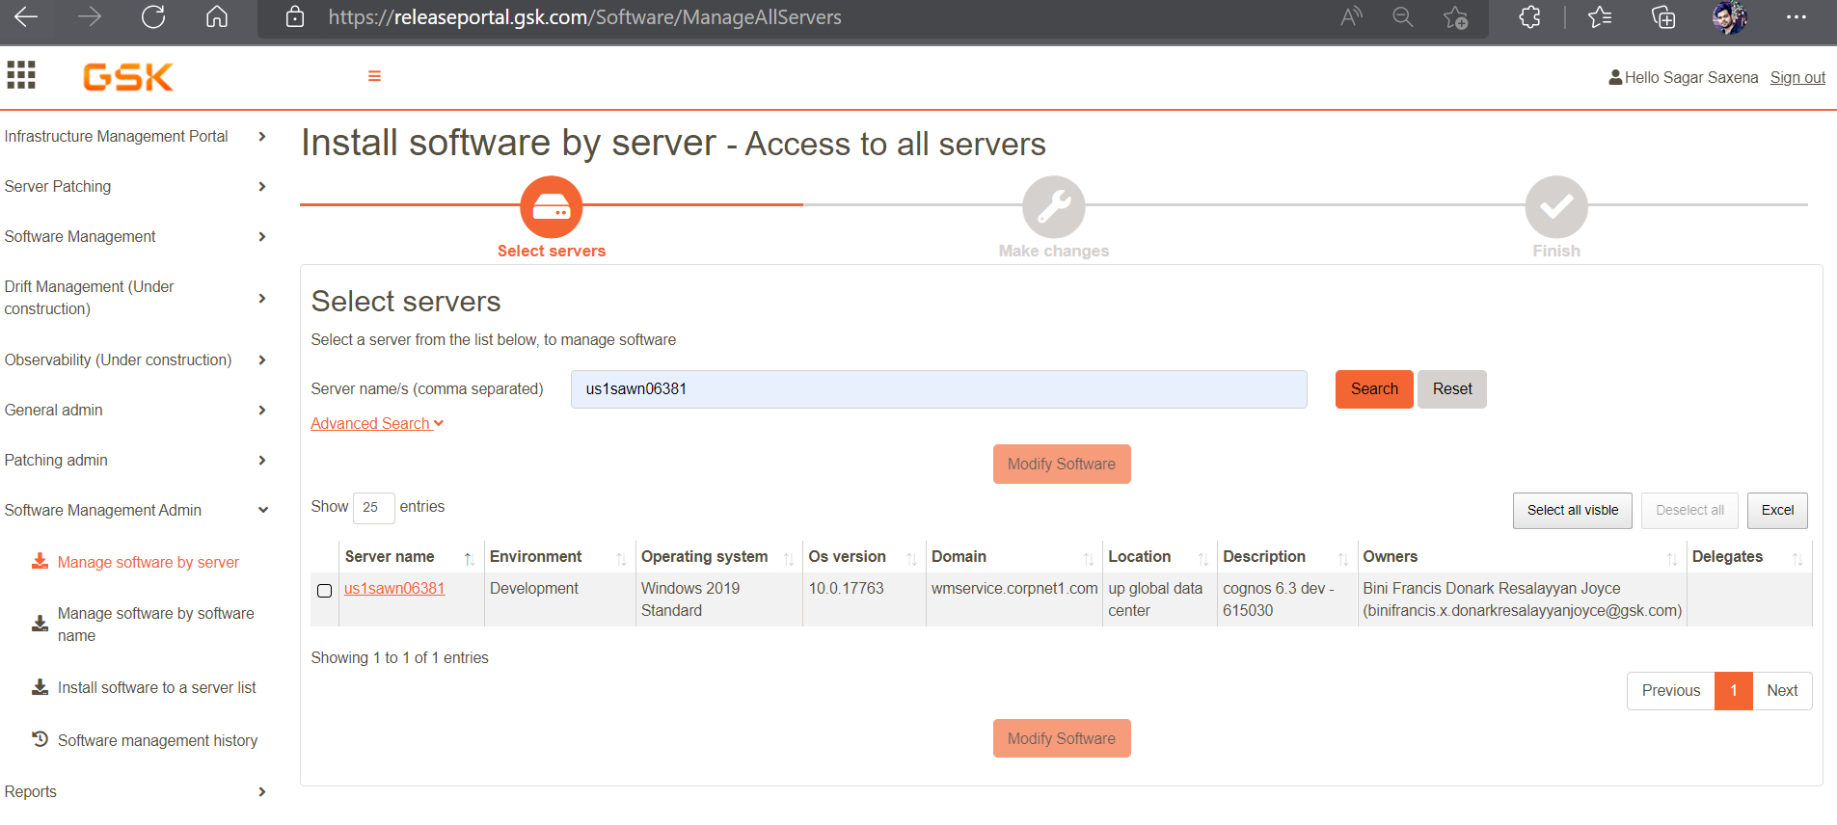

# Deployment Process

## Software Release on Limited Count of Servers

To Deploy software on limited count servers using Software Management tool follow below steps:

* Open Infrastructure Management Portal [Home - Server Infrastructure Management Portal (gsk.com)](https://releaseportal.gsk.com/) and in left pane Click on SMT admin and then click on manage software by server.

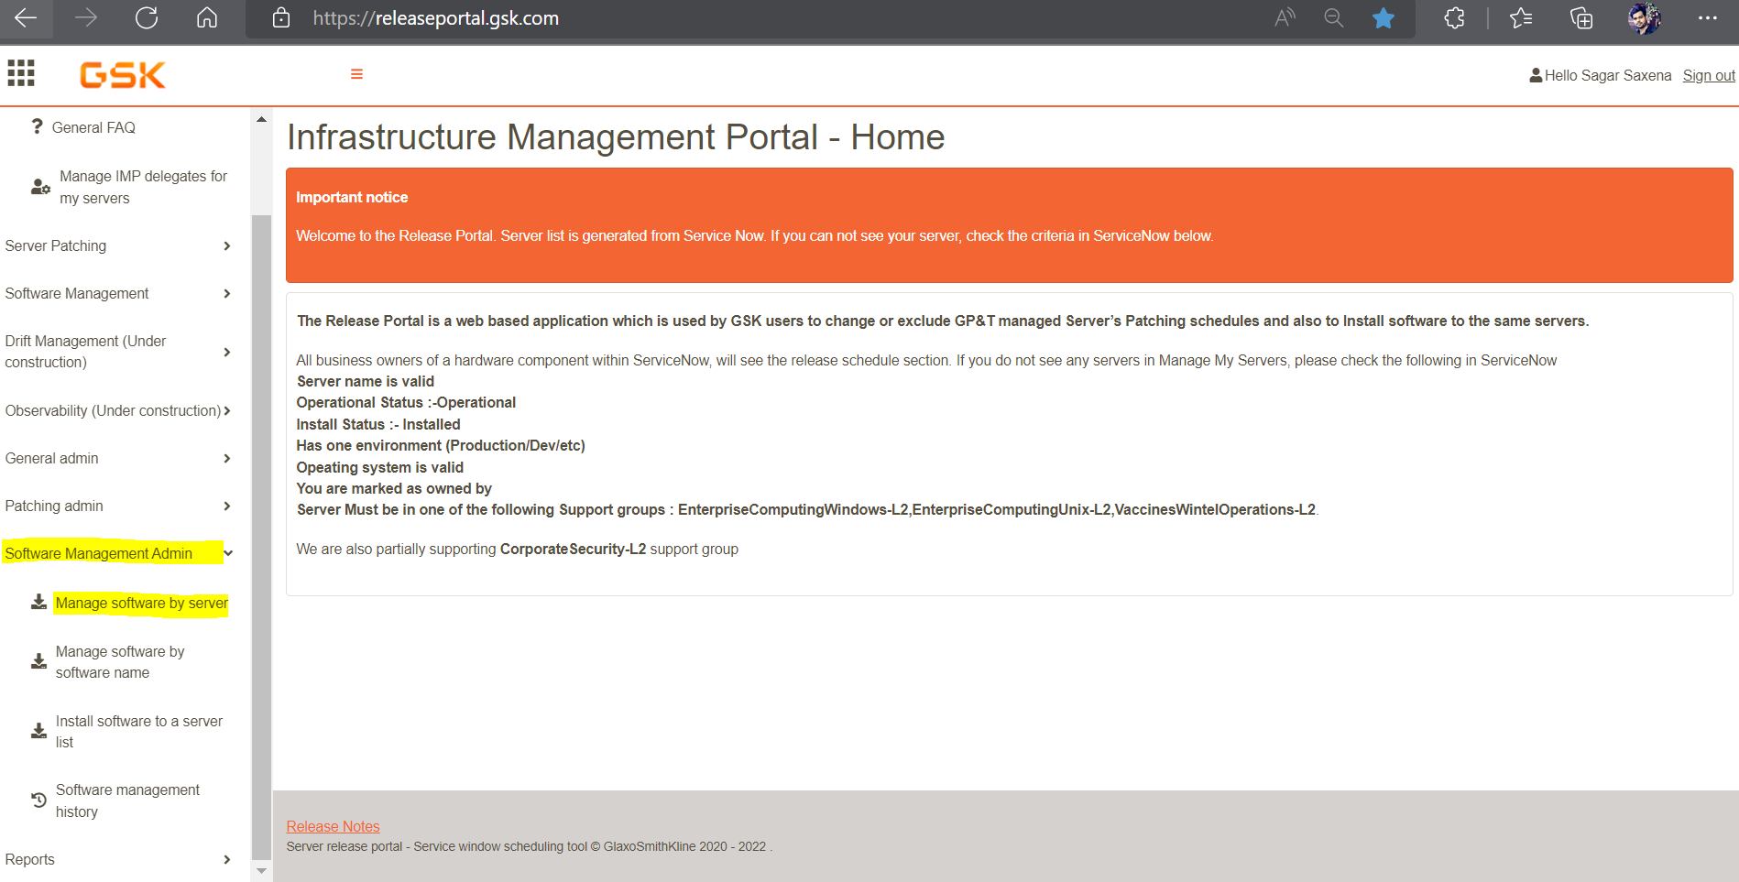

* Type the server name in “Server name/s (comma separated)” and click on search. You can as well search server by following criteria in Advance search:
  + Owner/delegate
  + Location
  + Platform
  + Environment

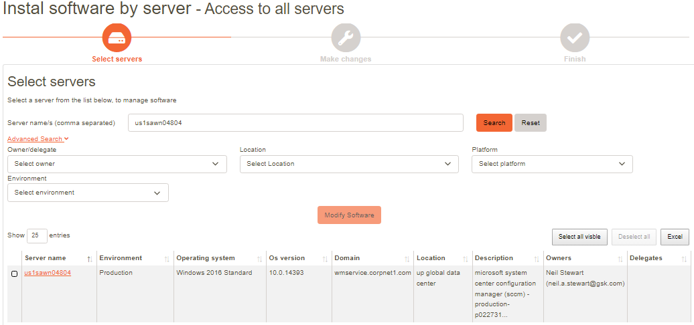

* Select check box and then click on Modify Software.

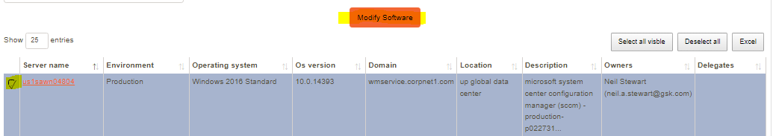

* Following below screen will appear after you click on modify software. Select date and time (UTC) as per the request to the software package.

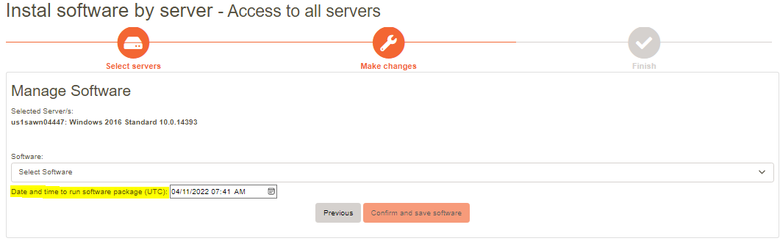

* To select the software that need to be deployed click on downward arrow. Select the requested software and then click on confirm and save software.

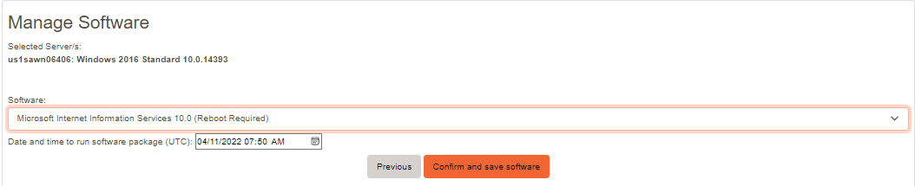

* Software installation will be initiated as per the given date and time (UTC).

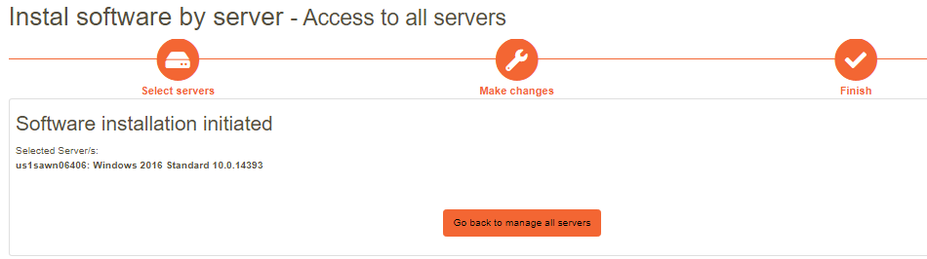

## Software Management Tool Software Deployment Monitoring

To Monitor deployment status in Software Management tool, click on “Software Management History” under SMT admin.

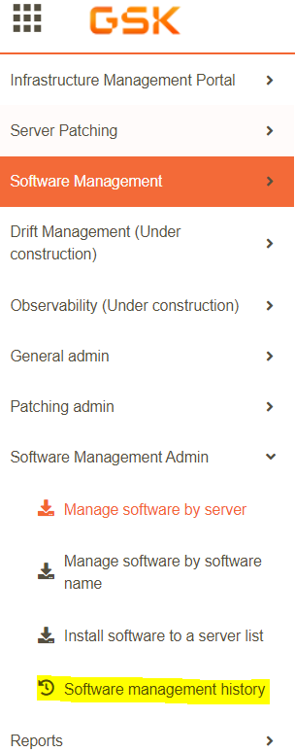

* Type server name separated by commas and click on search. You can as well past deployments by using advance search criteria like Software, change number, Completed status and schedule time.

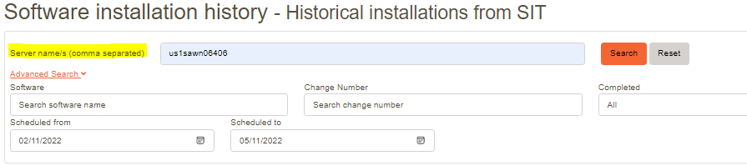

* After clicking on search, you will find all the details related to software deployment on that server like Software name, Change details and installation status:

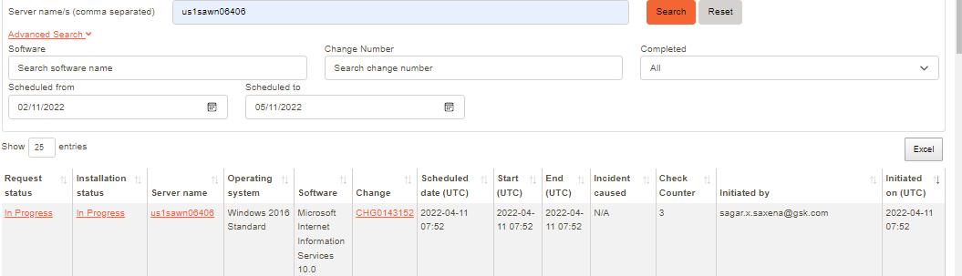

Note: If Installation get failed an Incident alert will get automatically raised and that can be as well visible under above monitoring “Incident caused”.

## Deployment Process of Software Release on Bulk Number of Servers

To Deploy software on bulk server counts using Software Management tool we need to follow below steps:

* Browse to Infrastructure Management Portal (<https://releaseportal.gsk.com/>) in the left pane under general admin drop down menu click on create list.

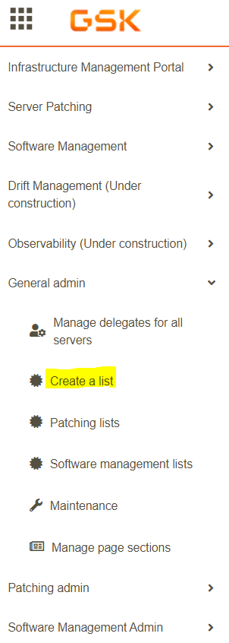

* Next window will appear “Create a list - Create and confirm SIT or Patching list”. Type the name of list as desired and click on custom server list.

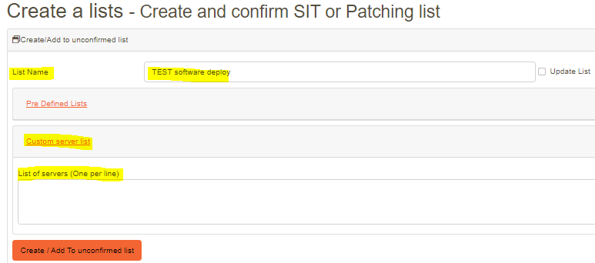

* Type all the server names (one per line) and then click on create/ add to unconfirmed list. On the same page below, we will see unconfirmed release list. Now click on view/delete/confirm details.  
  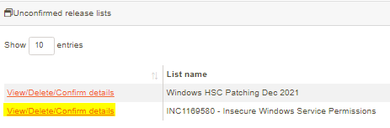
* After we click on view/delete/confirm details another page will open where you can verify the servers added to list before final list creation. Once you verify the list click on “Confirm Sit list (used for software installation)” as showmen below:

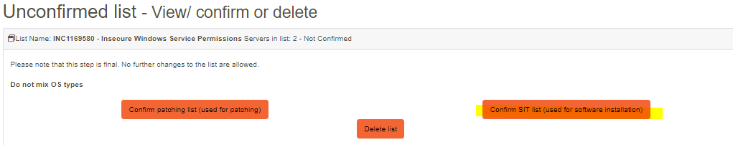

* After Creating list now again go back to SMT admin and click on Install software to a server list.  
    
  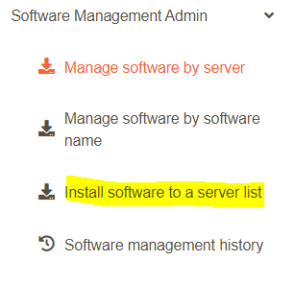
* Type the software name and fill in OS platform and click on search. You will find the software name click on it and select the list that we created and then click on confirm.

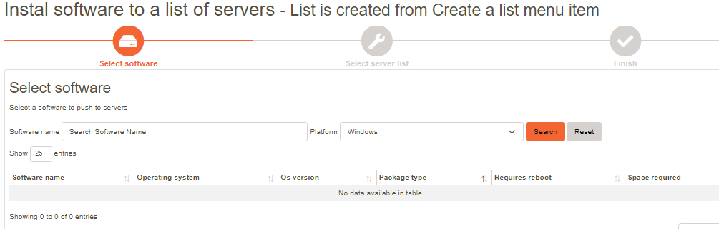

Note: Manual change creation and Software deployment is only performed post Exception/Approval.

# Request Handling (Manual/SCCM Deployment)

Any request via the CMDB/SN Platform requesting an Installation, Upgrade, or Uninstall of software on a managed server(s):

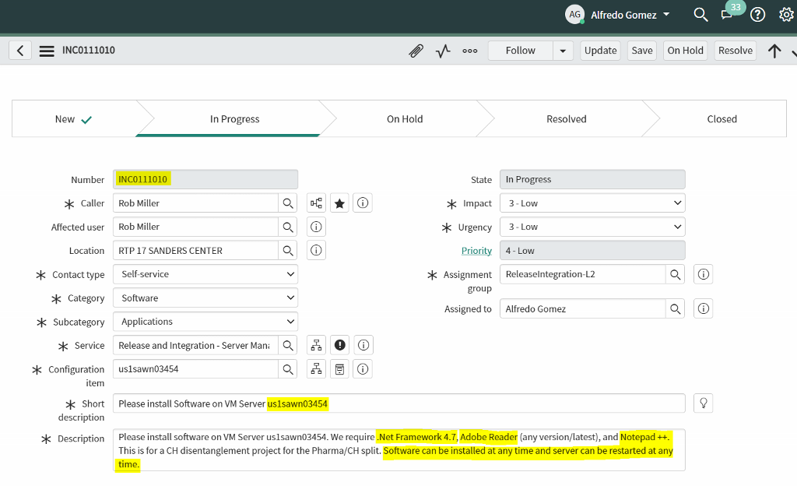

## Creating a Change Request for Software Installation on a Server

1. Navigate to ServiceNow and select the "Create New" option under Title "Change"

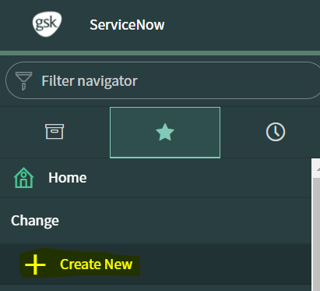

As this is a standard procedure, we can create pre-approved Changes using a template.

1. Select Change Type: Standard:

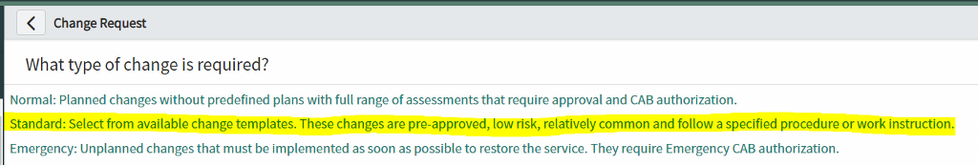

1. Type release in the Search bar and select "Software Package Release"

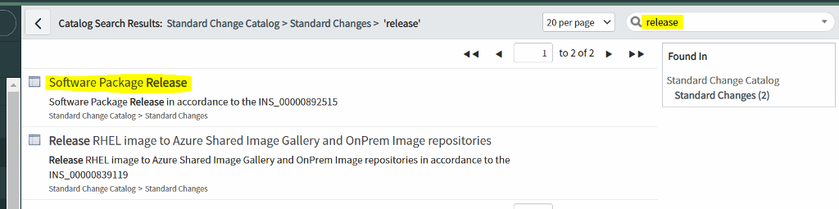

1. Fill out all required fields in the Change Request. (For reference you can use CHG0038876)

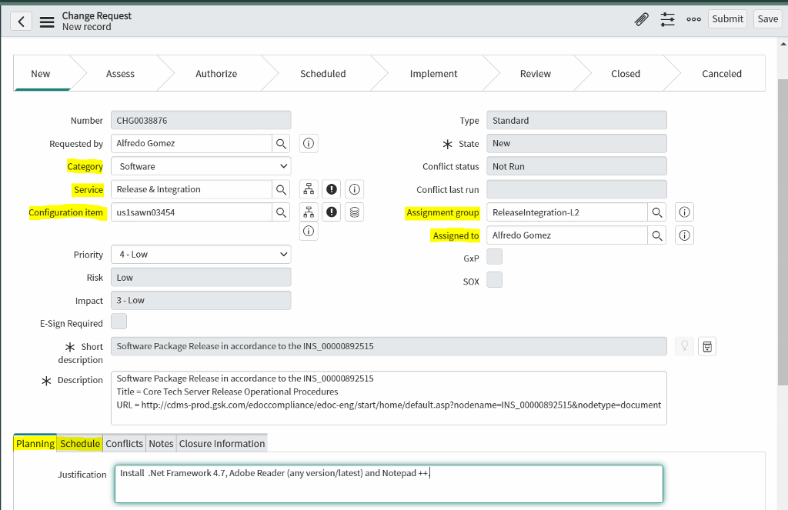

1. Once you have filled out the necessary fields, select the option to "Schedule" the Change:

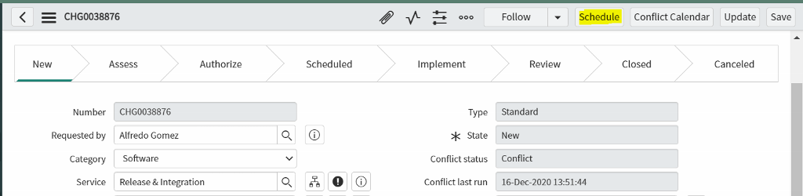

Note: There's no need to select the option to "Implement" the Change as this will happen automatically during the Planned Start Date / Time

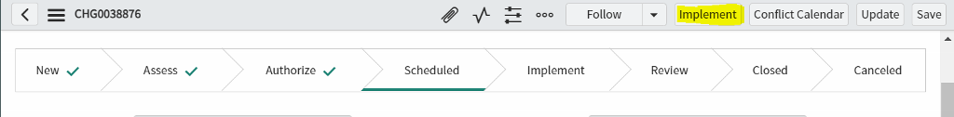

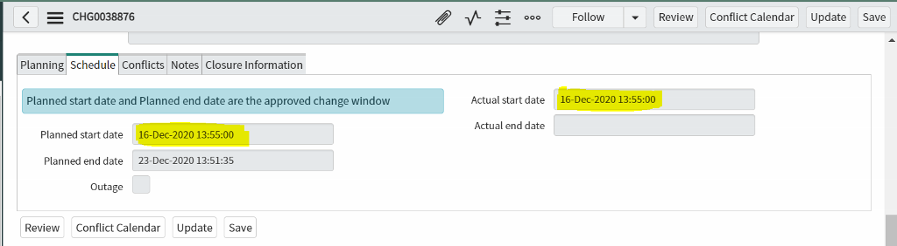

## Scheduling a Software Installation in SCCM

1. Log on to the SCCM Jump Server (us1sxwn09361) using your N-Account and open Configuration Manager Console

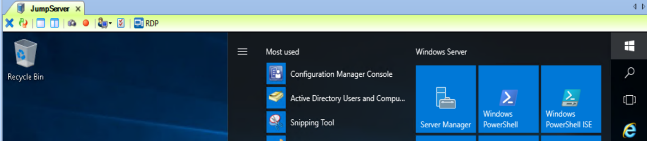

1. On the section "Assets and Compliance", Navigate to the following path:

Overview > Device Collection > Server Release - Device Collection > Targeted Releases

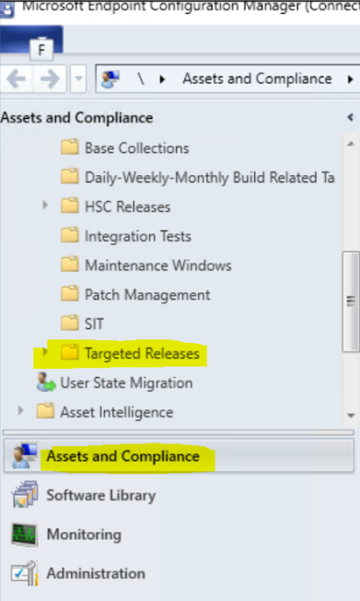

1. Create a new Device Collection in that directory using the appropriate naming convention "[ChangeId] - (Install/Unistall) [Software Required]"

1. Create Device Collection

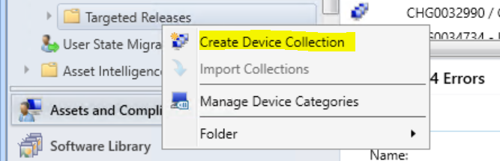

1. Type name and Comment:

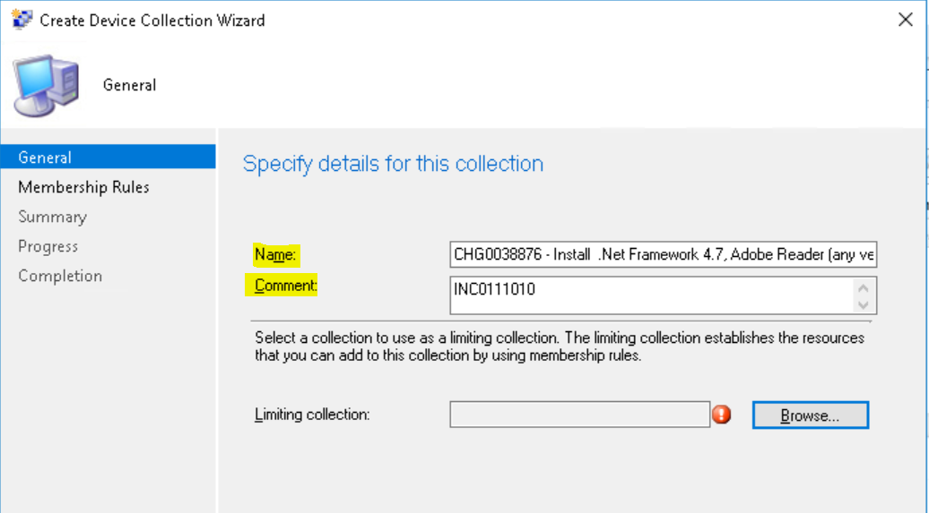

Note: Though it is not required, it is a good practice to include the Incident Number in the comment.

1. Select the Limiting Collection (Always use 'All Managed Server Systems') and click Ok, and then Next.

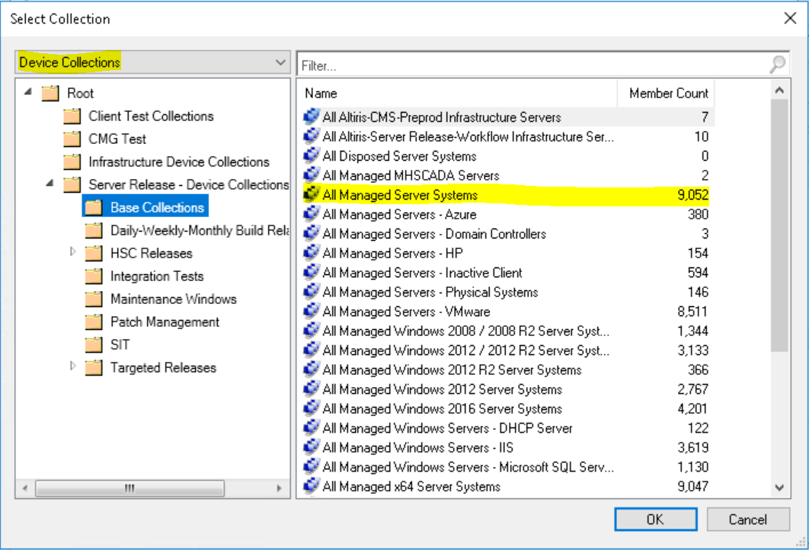

1. Select Membership Rules by clicking 'Add Rule' and selecting the appropriate option. Direct Rule: Add one or more servers searching by server name

Query Rule: Use a Query to add servers to the Collection

Other Options are rarely used but that may change in the future.

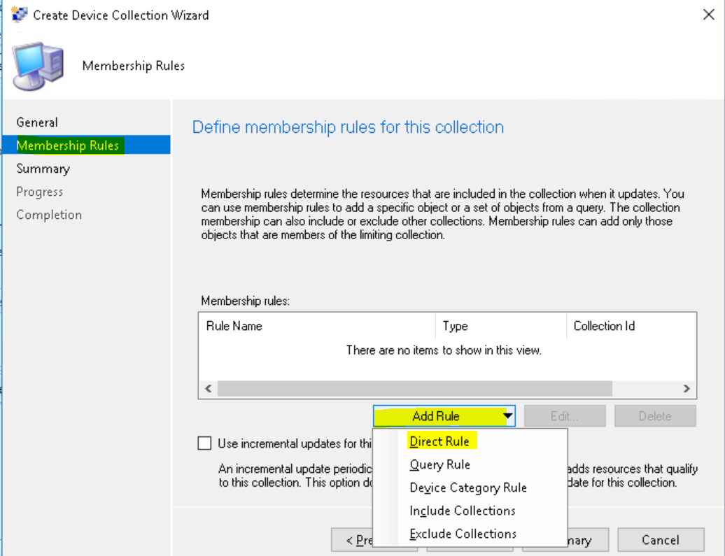

1. Clicking on 'Direct Rule' will open the 'Create Direct Membership Rule Wizard'. Click Next

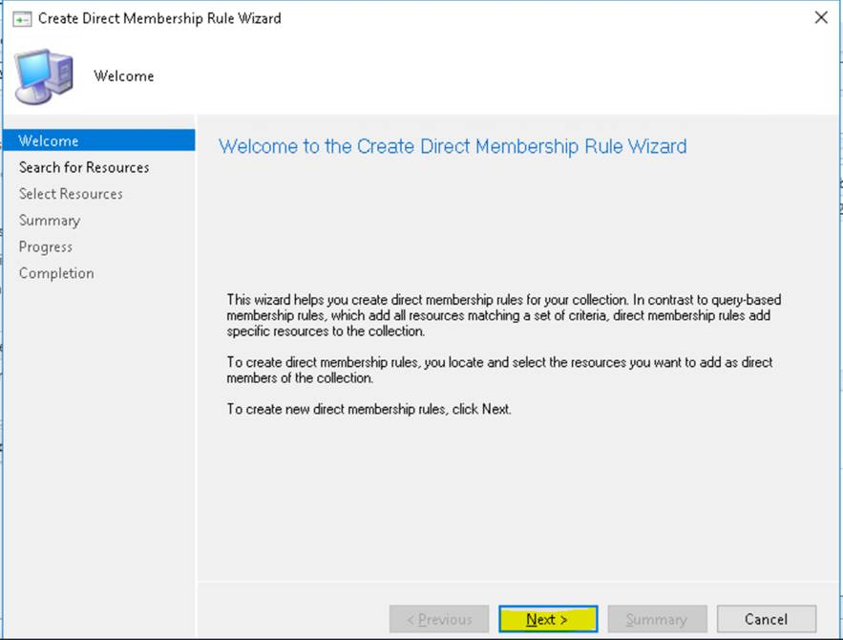

1. Type the server name or any other string of characters in the search bar. You may use '%' as a wildcard

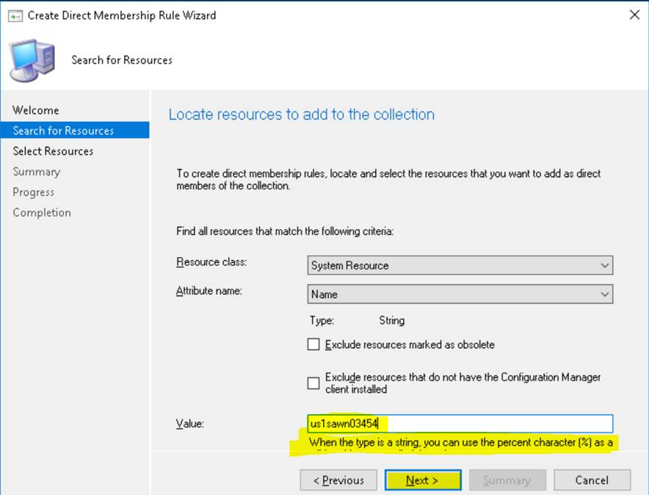

1. Select the resource(s) needed and Click Next

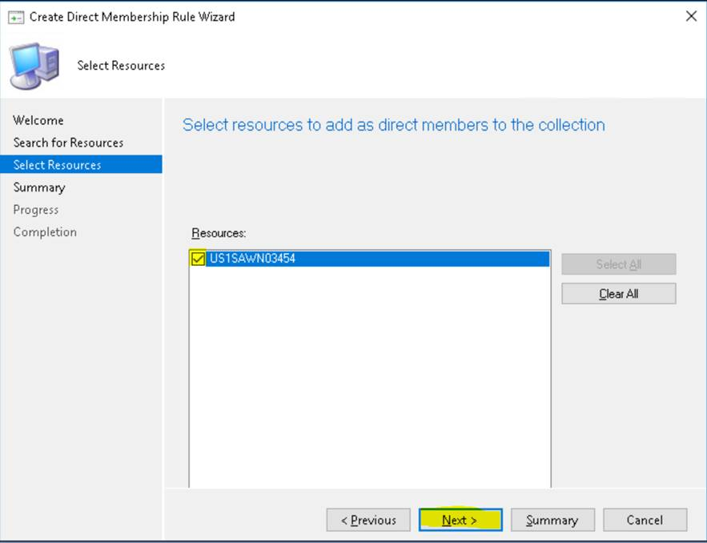

1. Click Next until you see the Completed Task and Close the Wizard

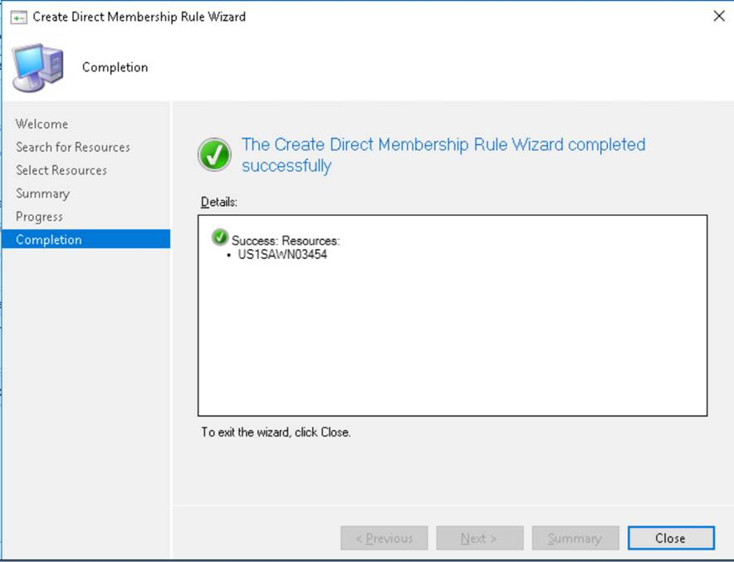

1. Once you see the required server(s) listed in the Collection. Click Next until the task is completed:

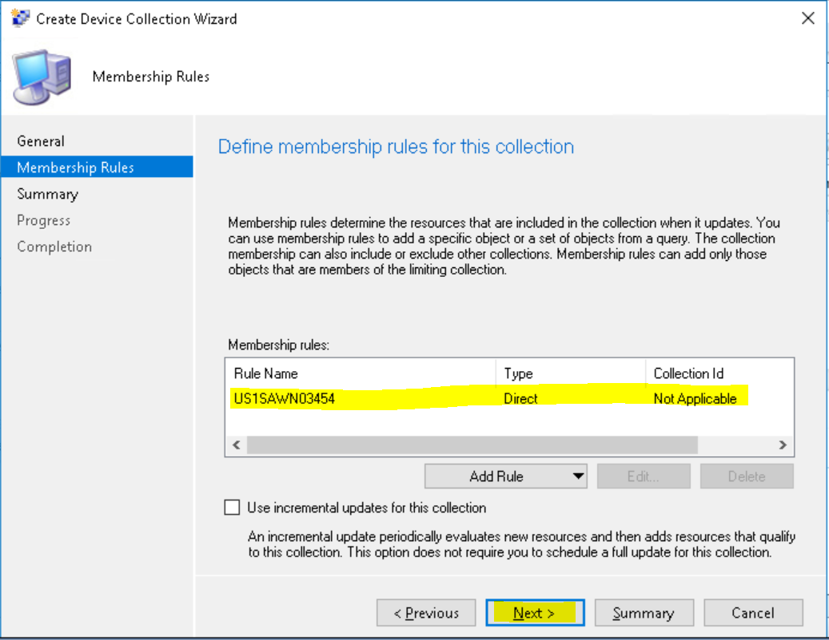

1. Close the Wizard:

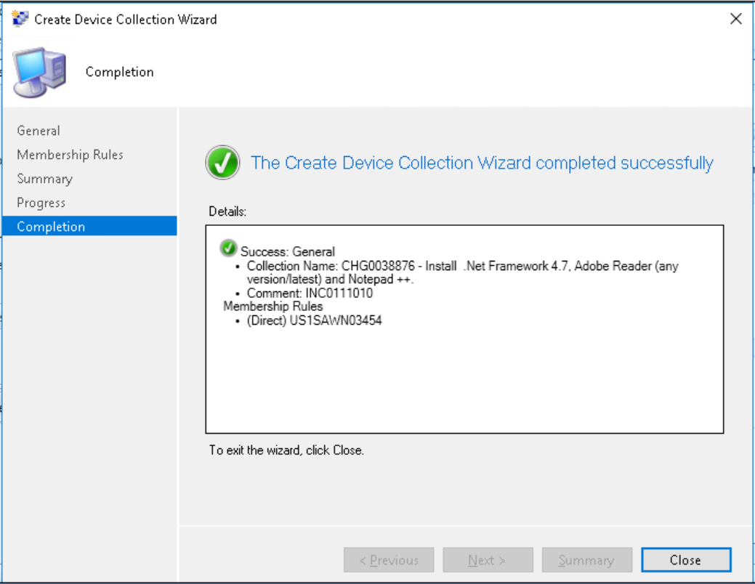

1. Now that the Collection has been created, we can move to the Software. In Section 'Software Library' Navigate to: Overview > Application Management > [Applications/Packages] > Server [Applications/Packages]

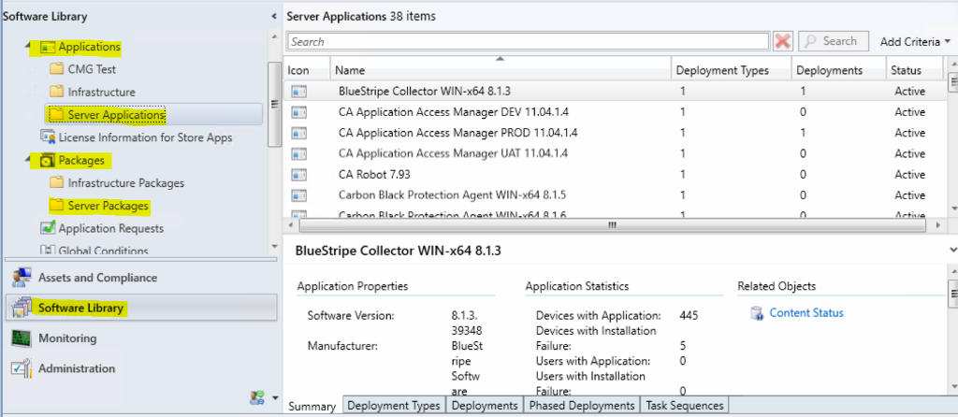

Note: If you don't have the 'Comments' Column, right click on the Title Bar, and add that Column to the View. This will have Reboot Information about each software

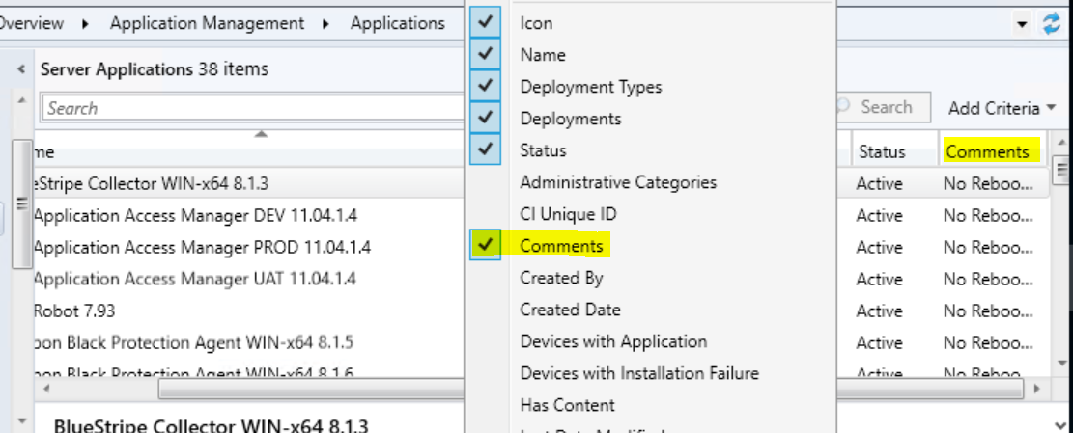

1. Find the required software in the list

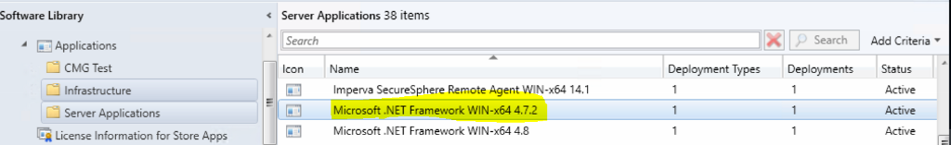

1. Right Click on the name of the software and Select Deploy

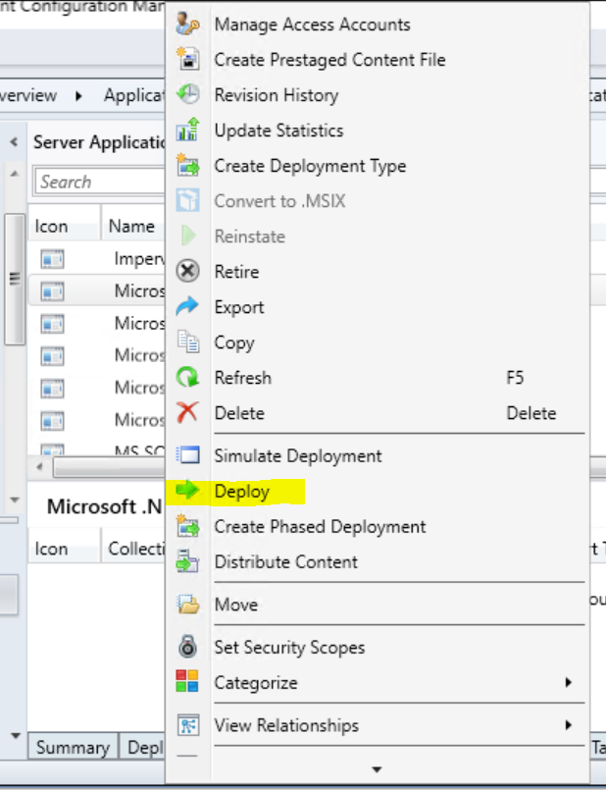

1. The Deploy Software Wizard opens

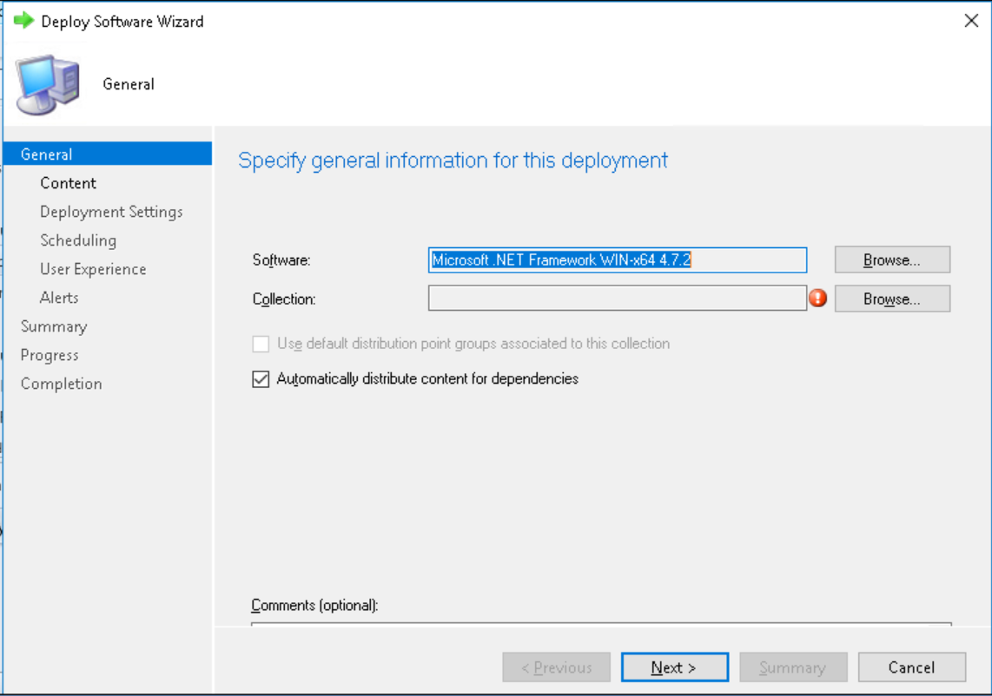

1. Select the Collection we just created in step d and Click Ok and then Next

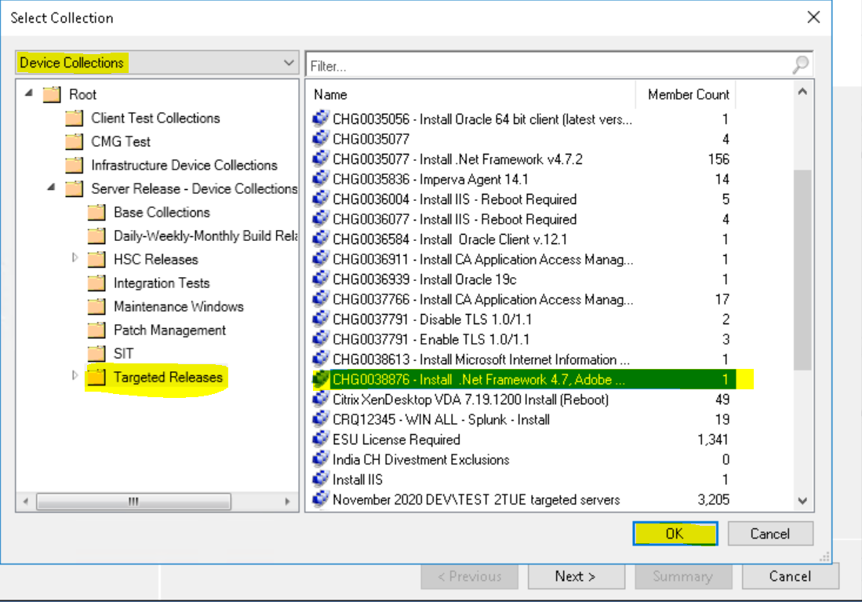

1. Wait for the Distribution Points to fully load. Click Next

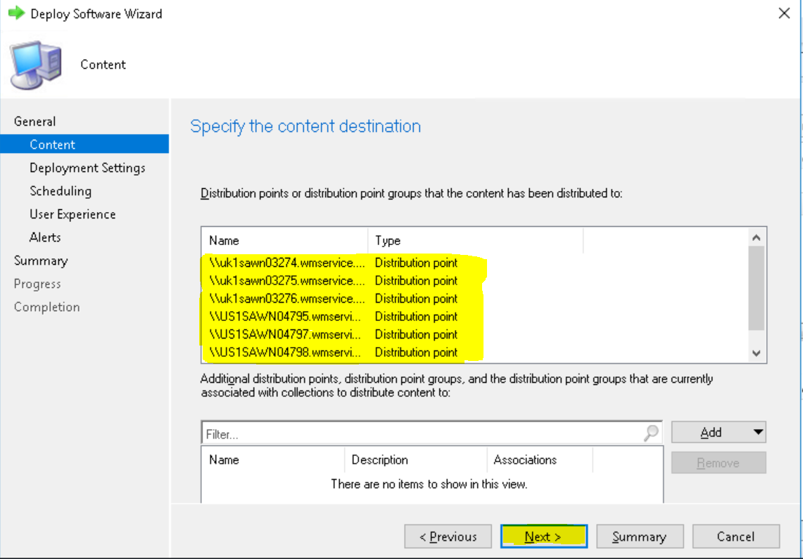

**If you require the software to be available for the customer to install themselves then follow steps 6.d to 6.f. Otherwise skip to step 6.g**.

1. Make sure 'Available' Option is selected and Click Next

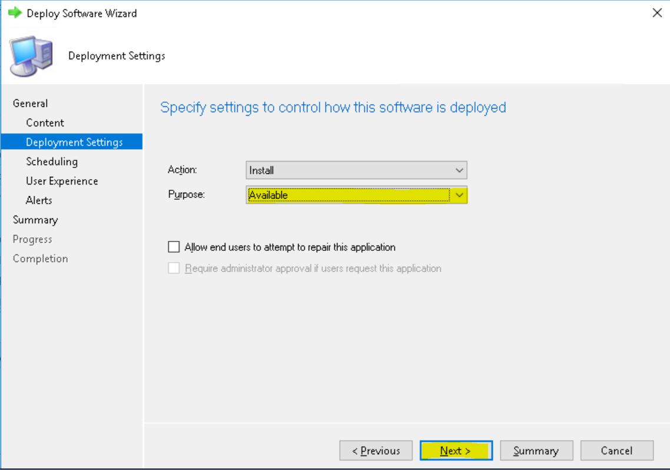

1. Unless you required a specific Schedule for the software to become available, on 'Scheduling', 'User Experience', 'Alerts' and 'Summary' Click Next.

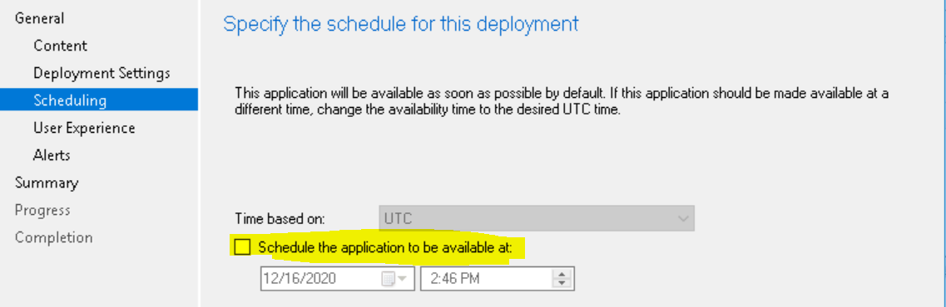

Note: In the Scheduling section you can specify a Schedule if needed.

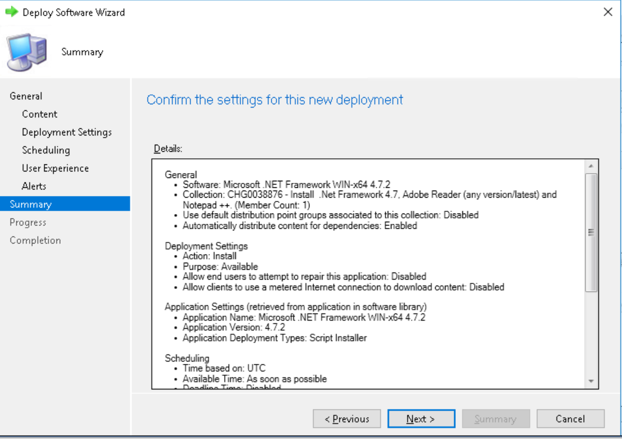

Software has been Successfully Deployed to Server. Customers can login to the Server and Install required software at any time.

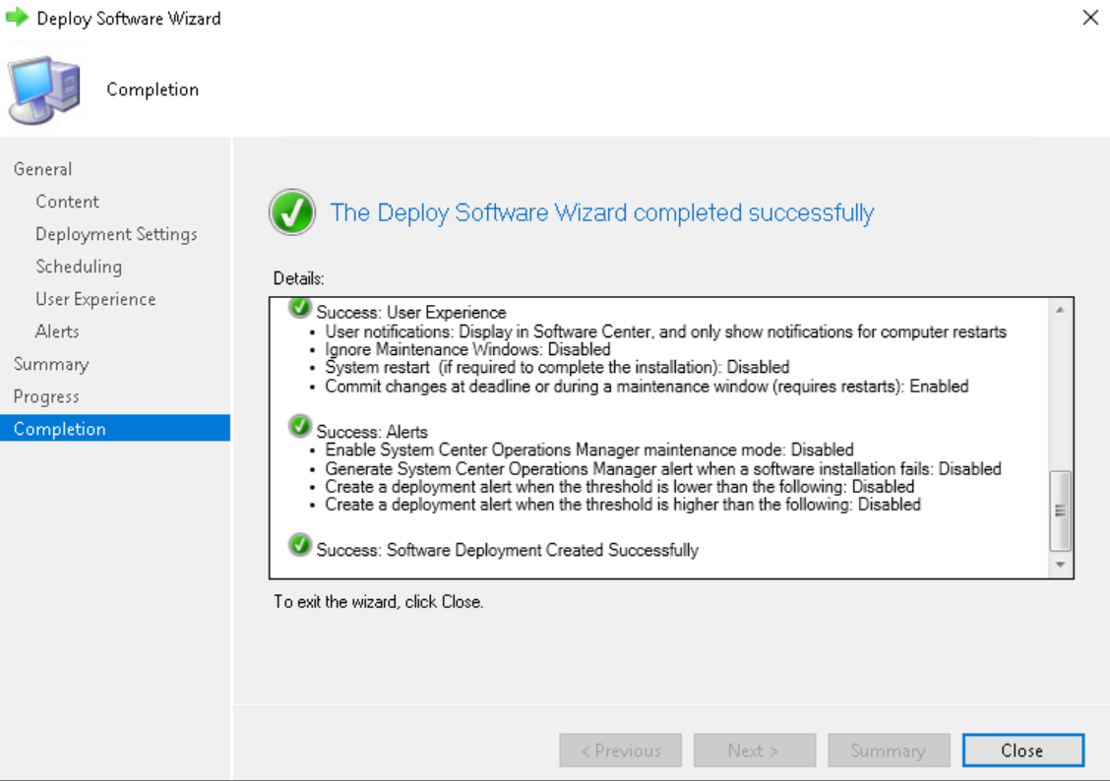

You can see the deployment in the Deployments Section in SCCM:

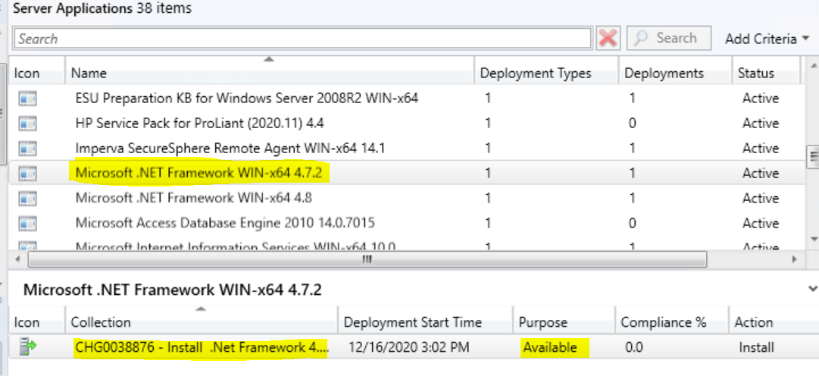

IMPORTANT: Repeat this process for all software required.

1. Select Purpose 'Required' and Click Next. (This option will automatically install and reboot the server. Beware)

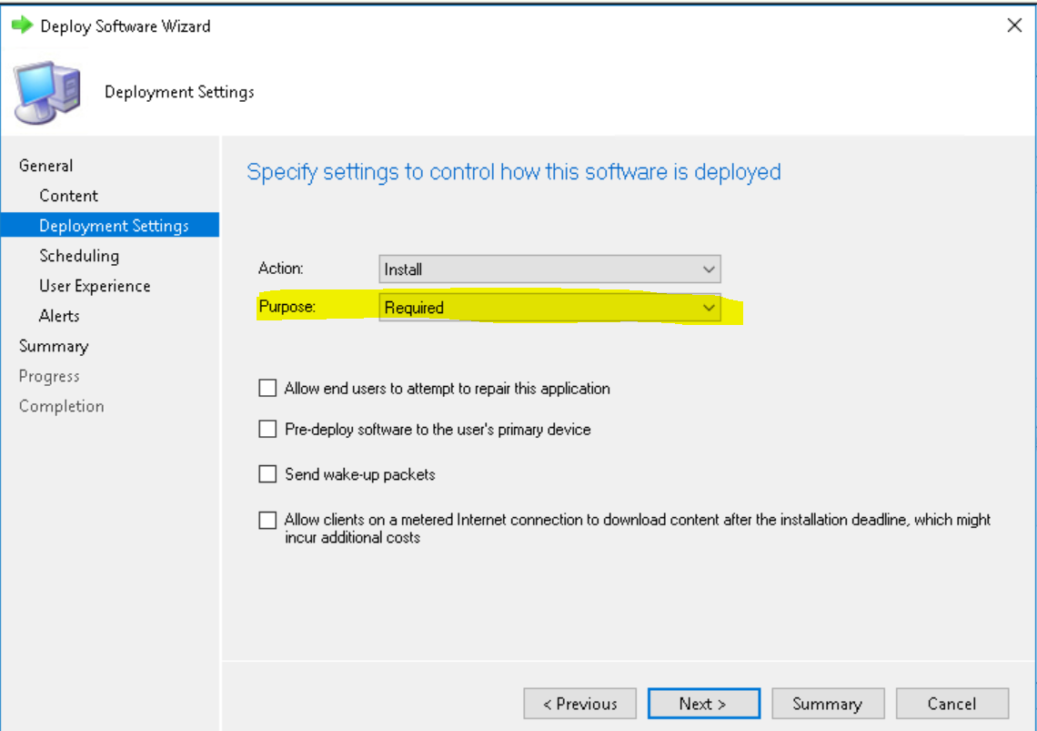

1. Select an appropriate Schedule. If you want the server to go immediately, just Click Next

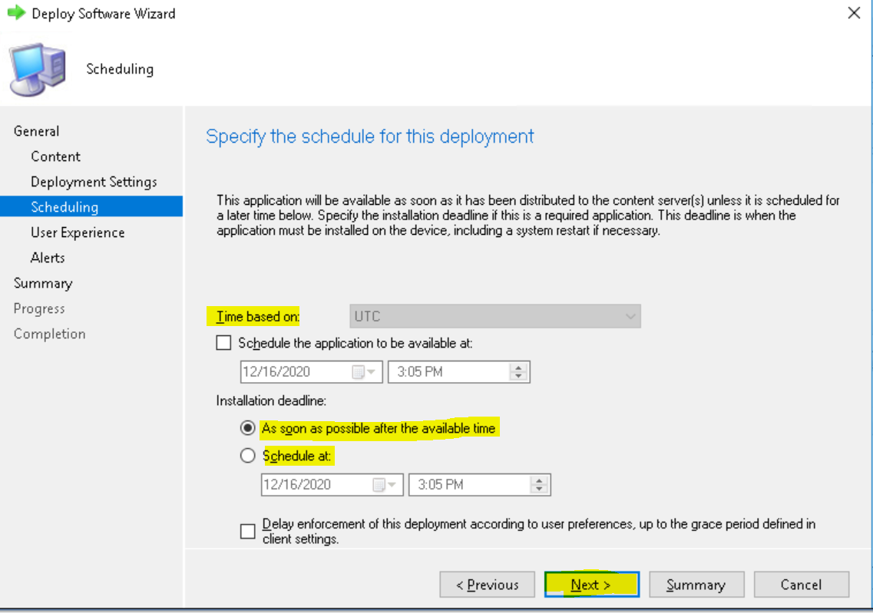

1. Select both 'Software Installation' and 'System restart' as actions to be performed outside of the Maintenance Window (unless the activity is taking place during their Maintenance Window)

Note: ‘system restart’ should NOT be selected unless it’s required by the software. Moreover, if this option is selected then we should have downtime approved by server owner.

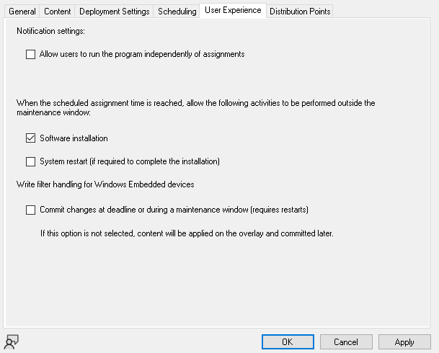

Note: If the software requires a restart and the option 'System restart' is not selected. The software will not be installed and will always fail. Always select both or if the restart needs to be done at a different time, then use the 'Available' option described in steps.

1. Click Next on Alerts and inspect the Summary. Once you're happy with it. Click Next

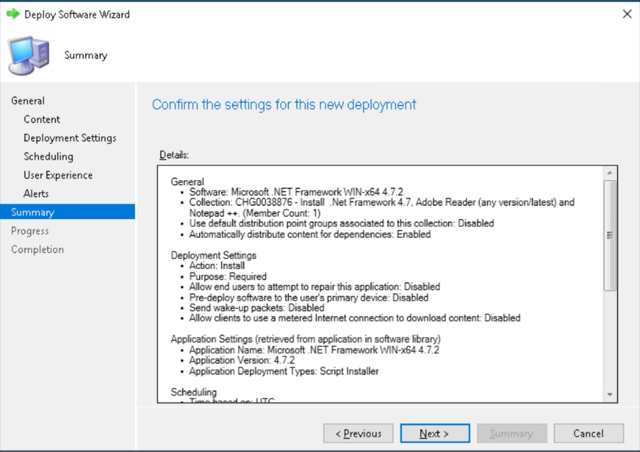

1. Software has been Successfully Deployed. Installation And/or Reboot will start shortly.

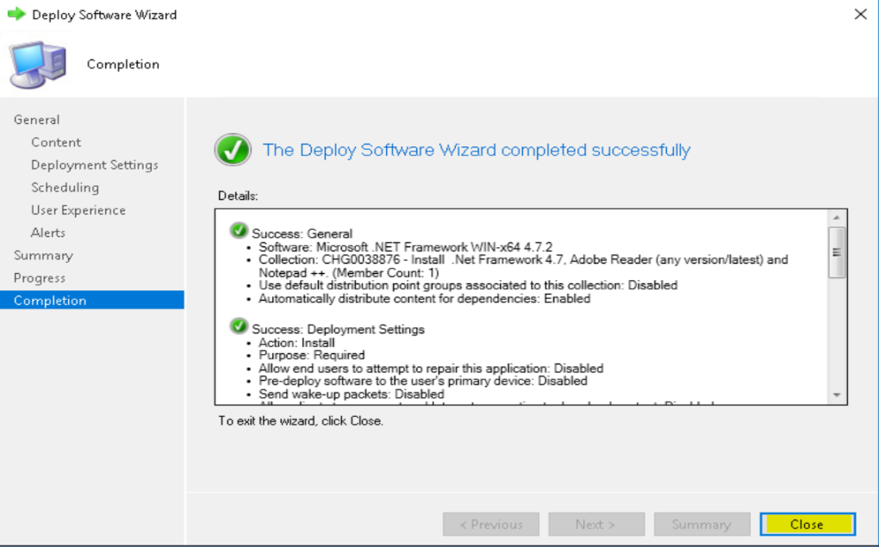

# SCCM Compliance Requirements

## SCA Requirement

Smart Controls Assessment (SCA): Smart Controls are defined to ensure that Tech systems meet GSK's Regulatory requirements and allow GSK to manage its main Tech risks which is done at the early stages of system development lifecycle in Archer.

SCA are Engineering /projects functions are mentioned in VQD Article Number:

VQD-REC-076978- Smart Controls for 119_Microsoft System Center Configuration Manager

My Learning Courses reference - TEC-180-IT-1120 Smart Controls Assessment Procedure (SOP-IT-1120).

## System Access Plan

System Access plan is mentioned in VQD Article Number:

VQD-PLN-012937- System Access Plan for System Center Configuration Manager (SCCM)

## Operations Manual

Service Design Package (SDP) or Operations Manual (OM) are the accountability of GSK Product team. Operations Manuals are published in Veeva, and new documents will be managed by GSK product team with collaboration from HCL and also the documents are managed in teams’ group.

[Link to Operations Manual](https://myteams.gsk.com/:f:/r/sites/ModernWorkspaceHCLSupportGroup/Shared%20Documents/SCCM%20Infra/Infra?csf=1&web=1&e=m8NoXf)

VQD-REC-076961- Operations Manual for System Center Configuration Manager (SCCM) **Note:** Only GSK authorized users can access the repository and will need an GSK account and Citrix VDI.

## Disaster Recovery Management

Server Release team is not performing any DR activity.

## SOX Audit Requirements

SOX audit is not performed by the Server Release team.

## GXP Server Release Requirements

We cover application and package deployment on R&D, Manufacturing Servers. Although Server release team covers mandatory on demand Package and application for R&D, Manufacturing, there is no additional training required apart from standard myLearning GxP awareness trainingsTEC-180-497: Core Tech GxP Awareness (myLearning)

## Risk Management

Risks are the accountability of the GSK product team and will be managed and tracked in Archer. Risks will be reviewed with Product team service manager and HCL. Risk remediation will be a collaborative effort between GSK product team, service manager and HCL.

## Vulnerability Management

Vulnerability Management is the accountability of the GSK product team. Vulnerability remediation will be a collaborative effort between GSK product team, service manager and HCL. Vulnerability that cannot be remediated in the required timeline will be made exceptions and added to Archer.

## ServiceNow Management

HCL will have required access to ServiceNow for incident, service request, change & problem management. Component management and ownership is the accountability of the Product team. ServiceNow trainings for HCL are part of standard training which is mentioned in Section 11, “Training Requirements”.

**ServiceNow** **Resolver group**:

1. ReleaseIntegration-L2

**Ticketing System:**

Kindly find enclosed updated URL of ticketing tool used in GSK environment:

* **ServiceNow**

**Step 1**: <https://gsk.service-now.com>

**Step 2:** click Incident- Create New

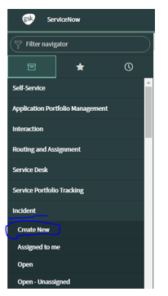

**Step 3:** Fill all mandatory details

Contact type: Chat

Category: Software

Subcategory: server

Service: Release and Integration - Server Management

Configuration Item: master host name

Assignment Group: ReleaseIntegration-L2

Short description: Need to Update short description

Description: Need to Update Description

**Step 4**: Submit

## Automated Tools/Process

Software management portal ([Manage software on all servers - Server release portal (gsk.com)](https://releaseportal.gsk.com/Software/ManageAllServers).

## Mandatory Training & Requirements

Mandatory and required trainings that needs to be completed are added in Section 11, “Training Requirements”.

## Management Monitoring

List of reports we share to GSK Server management are:

1. Installation incidents assignment queue check – ServiceNow report - daily
2. Incident mgmt. in/out of SLA – monthly check (OneNote)
3. Service requests report- weekly
4. Change requests report- weekly
5. Weekly improvement progress and meetings.

# Training Requirements

All personnel using this Standard Operating Procedure shall read and understand the content of this document and record this in their training records.

Training records for both permanent staff and contracted resources are maintained in the myLearning system as detailed in Management of IT Training and Records, SOP-IT-1117, VQD-SOP-006253 [2].

Creation of training records should be done by completing the myLearning module associated with this procedure TEC-185-073085. If the myLearning module has not yet been created for this process, personnel should use the Record Learning feature to create a record in myLearning.

Personnel working for a Third-Party organisation shall maintain training records according to their Company's standard approach and these shall be to a standard that meets GxP regulations and in compliance with GSK Contractual Requirements.

SCCM team must completed all below listed trainings in myLearning to get access to systems.

| **Training ID** | **Title** |
| --- | --- |
| BUS-L-VQD-GUI-005718 | CyberArk User Guide |
| SOP-IT-1121 | Procedure for Control of Privileged Operations |
| STD-IT-0015 | Access Management Standard |
| SOP-IT-0015 | Access Management Procedure |
| TEC-180-801 | Management of IT Training and Records Overview |
| SOP-IT-1117 | Management of Training and Records |
| TEC-180-549 | Privileged Access Certification Overview |
| SOP-IT-0009 | Tech Change Management Procedure |
| TEC-180-543 | Access Management Controls Overview |
| TEC-180-752 | Tech Risk and Non-Conformance |
| POL-IT-0002 | Tech Control Framework Policy |
| TEC-180-752 | Manage Service Risks |
| TEC-180-227 | Tech Control Framework Policy Overview |
| BUS-CBS-PHS-001_EN_2021 | Phishing Guidance for people who have fallen 1st time this calendar year |
| BUS-PAP-LOVE_2020 | Living our values and expectations: Protecting GSK |
| BUS-PAP-INCLUS_2020 | Inclusion and Diversity at GSK |
| SOP-IT-0002 | Problem Management Procedure |
| BUS-PAP-PRIV_2018 | Privacy Foundations 2018 |
| TEC-180-497 | Core Tech GxP Awareness |
| SOP-IT-0288 | Manage Documentation |
| SOP-IT-0034 | Manage ITMS Deliverables |
| GUI-IT-0317 | ITMS Fundamentals |

# Glossary

| **Term** | **Description** |
| --- | --- |
| SLA | Service Level Agreement |

# References

| **Item** | **Document ID** | **Document Title** |
| --- | --- | --- |
| 1. | VQD-SOP-006047 | TSR Document Management Plan for Veeva QualityDocs (VQD), |
| 2. | VQD-SOP-006253 | Management of IT Training and Records (SOP-IT-1117) |

# Revision History

| Version | Reason for Revision | Template Version Used |
| --- | --- | --- |
| 2.0 | Up-versioned the SOP template to version 5.0  Up-versioned for the 1-year technical review. | 5.0 |
| 1.0 | This is the first issue of this document. | 5.0 |

# Appendices

None.